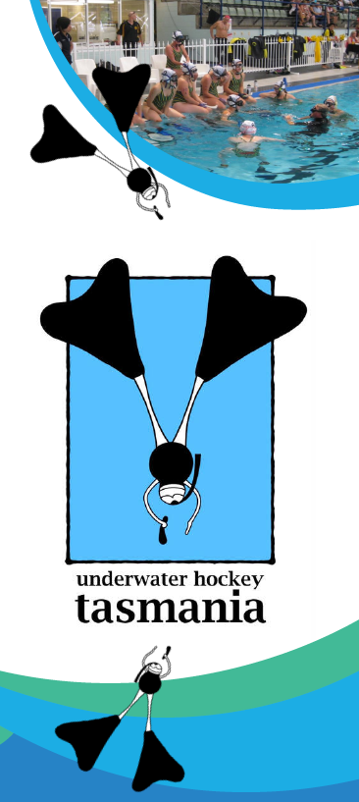 | Schools - Underwater Hockey  Experience speeding through the water in a pair of fins, mask and snorkel and playing a fun game under the water with your friends.  Our first 2021 Come and Try session commences on Thursday the 22nd of April at 7.30 pm – 8.30pm.  All Underwater Hockey gear is provided – BYO bathers and towel.  Entry is free for the first session.  Register your interest by sending an email to natalie.wickham @education.tas.gov.au with your name, grade and school details.  