Information Package
New Zealand Schools
Underwater Hockey Championships
Wellington
30th August – 5th September 2016

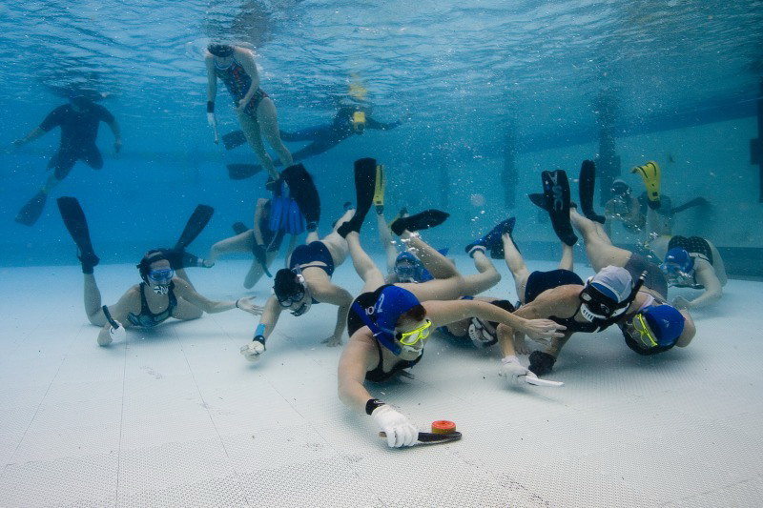
It’s great to see so many new players keen to represent Tasmania at the New Zealand Schools Nationals Underwater Hockey Championship, and welcome back to those players who have represented Tasmania before.

The Competition
Each year New Zealand holds an Underwater Hockey Schools Nationals Competition. The very best teams from all over New Zealand who have qualified come to compete in this event with 4 divisions – U15 open, U15 girls, U19 open and U19 girls. Tasmania is lucky enough to be invited each year. 2016 is the 32nd year of this event so it will be bigger and better than ever.

Because we are not a New Zealand team we cannot win the event, but we can win the round robin. Because we come all the way from Australia they make sure we get plenty of games, and usually play all the teams in our division.

The games are fast and furious and we can play up to 7 in a day so you certainly get your money’s worth. In the past we have sometimes won every game, and sometimes lost every game and mostly it is in between. But it really doesn’t matter as the whole aim of going to this competition (comp) is to have heaps of fun, improve your hockey and get to play some really high level games. We use this comp to develop players. No matter what your ability is now it will be much better by the time you get back.
The Trip
As well as the Underwater Hockey Competition we try to make this just a fun trip.

Support for the players/contacts
It is important that parents of players are aware that Team Managers and Coach are volunteer parents or players who are giving their time to help make this trip possible.

Team Manager
Sharon Williams ph 0400913490 email dsswilliams@bigpond.comt

Coach
To be decided

Parents are very welcome to come on the trip and help out. Please let me know if you need accommodation with the team. Parents need to pay for their own trip, and organise their own transport during the trip.

Training
To be decided and advised by coach when appointment but expect to be 2 – 3 nights per week.

Documentation
If the trip goes ahead all players wishing to be considered for the team are required to fill in an information form, a player contract signed by player and parents, and a medical information form. Players/accompanying parents also require a valid passport. If you do not have a valid passport you cannot fly.

Selections
Depending on the number of players wanting to come we may need to have selections.

Payments
The payments are an estimate. We spend a lot of time researching this and try to slightly ‘over budget’ but parents must be aware that it is an estimate and the final cost may be a little more. The two most variable factors are airfares and the relative cost of Australian /New Zealand dollar. At the completion of the trip all players will be given an invoice of their costs and hopefully a small refund.
Below is the breakdown of the costs for the trip.

Flights $865
Accommodation $270
Team Entry $34
Bathers $35 for the boys $50 for the girls
Uniform (warmup pants, shirt, hoodie) $105
Coach Uniform $10
Food $180
Vehicles (minibus/s and Managers car) $82
Fuel $35
Tourist Items (Fun things) $100
Plus extra just in case $75
Total Estimate $1800

Additional costs not mentioned above:
All players who represent Tasmania need to be full of the Australian Underwater Federation’. Cost $40 for juniors if join before 31st July

There will be some cost for pool training at Clarence Aquatic Centre – to be confirmed if the coach decides to train on a Sunday at this pool.

Also flights may be dearer as it is very close to when we actually go.

Travel insurance
All players are responsible for their own travel (including medical) insurance.
The Team Managers will seek Medical Assistance/advice for your child – if there is any doubt or any medical condition.

This will be at the local General Practitioner, hospital or via ambulance. Parents need to realise that Team Managers and Coach are parent volunteers or players with no medical background and will seek Medical Assistance/advice for your child.

Time table for payments
To be advised but due to the short time frame till we go the majority of the money will need to be paid within the next couple of weeks.

Bank Account details
Bank: ANZ
Account Name: Tasmanian Underwater Hockey
BSB: 017010
Account Number: 2098 74331
Please remember to write your name as a reference

