Treasurers Report FY 2014-15
It has once again been a busy year for TUHA finances, most notably because of the continual evolution of our switch to online finances and database management. For those that weren’t aware we were forced to move to an online payment system (as other pool users forced the hand of the council, and the pool will no longer collect private booking money). It has been the largest budget year on record (outside of hosting worlds) due largely to the number of travelling teams.
The bank change to ANZ has seen a decrease in our bank charges, increase in our interest returns, and made management and transfer of funds simpler for the committee.
The new online membership system was brought about through necessity, though it is not perfect and has had its teething problems, which I/we apologise for, it was the most cost effective and easiest option for the association to manage. Updates this pennant allow us to keep accurate and current databases of players and payments. Moving forward we will continue with the same system and refine it to be as easy as possible. AUF and TUHA memberships remain separate, which will allow members to take advantage of all the discounted options for AUF memberships (family, 4 year etc etc). I am more than happy to discuss other options for how we can manage funds, and to help anyone having any issues with the system. We all appreciate your effort and patience during the transition.
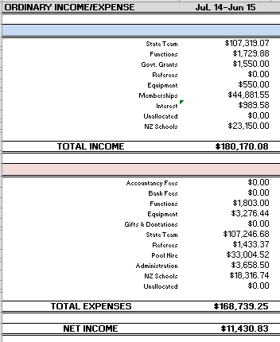
FY 2014-15 Summary:
The large Net Income is accounted for by outstanding Pool Hire invoices that we are waiting for. Major Income and expenses as usual were the state teams travelling, a HUGE thankyou to Sandra Milner who did an outstanding job, managing funds in excess of $100k she managed to balance the books out. Also Deb Davies this year managed the NZ Schools trip, a huge thanks to Deb for her effort. As usual Pool hire is our largest association cost and we continue to investigate ways to minimise this cost
Administration consists of re-imbursements for Christian and Mark whose continued effort and support at the front desk keeps Wednesday nights functioning, costs of sending representatives to UHA AGM and other general costs of keeping the organisation alive. Another outstanding expense is payment for Referees, this has been factored into membership income and will be payed out before the end of the financial year.
Any questions or if anyone wants the job of treasurer, feel free to email me. Nick Martyn - TUHA Treasurer

