2014 UWH Nationals Accommodation Package

Tweed Gold Coast Freedivers (TGCF’s, Ian Brown) have made a tentative booking for 224 guests from 21 January 2014 to 28 January 2014 at the Tallebudge​ra Active Recreation Centre. This is a stay and play accommodation package. The centre is on the beach and river at the Northern end of Palm Beach (refer Accommodation photo) and only 4.8km (7 minutes drive, refer Directions photo) to the competition venue.
The beds available for the above dates are in the following format:

5 single story buildings, all with ceiling fans, each accommodates 32 people in:
- four standard rooms with seven beds, ensuite, table and chairs in each
- one leaders' room with four beds, ensuite, table, chairs, fan and kitchenette with sink, microwave, mini-fridge, crockery.
1 double storey building, with ceiling fans, accommodating 64 people in:
- eight standard rooms with seven beds, ensuite, table and chairs in each
- two leaders' room with four beds, ensuite, table, chairs, fan and kitchenette with sink, microwave, mini-fridge, crockery in each.

TGCF’s wish to invite each competing state to make a block booking of a building. Considering the single story building it could accommodate 3 teams of 10 players + 2 coaches. For example Elite men's, Elite women's + Juniors or Masters teams. If WA, Vic, Tas, NSW, SA or Qld were to take up the offer this would be the five single storey buildings filled. The double storey building is available for any larger teams or combinations.

Bookings are made by the building so if a Team was to take up the offer they would need to book all 32 beds (or 64 in the double storey).

As you can imagine we are trying to create an athletes village style of accommodation arrangement to promote a social aspect to the event. If partners and families of competitors wish to attend can they please contact TGCF and we can attempt to accommodate at the centre.

The cost per person per night is $35 x 7 nights = $245 per person (very competitive). Meals are also provided by the centre at a cost of $10 per meal, $15 for a larger portion. We encourage breakfast and dinner be taken as part of the package with competitors organising their own lunch. Total cost for 14 regular portion meals = $140. Total cost for 14 larger portion meals = $210. We assume larger portion meals will be required. If you would like a variation of the accommodation / meal arrangement please contact TGCF’s to discuss.

As such total cost for 7 days accommodation + 2 larger meals per day = $455. We propose this information be circulated to the States and encourage a prompt reply with block team booking requirements. Building selection / allocation would be on a first come first served basis with a 25% non-refundable accommodation deposit ($245 x 32 x 20% = $1960) payable to Tweed Gold Coast Freedivers securing a booking.

Final outstanding payment balance, including meals, ($14560 - $1960 = $12600) is to be made by 7 November 2013.

This is a great accommodation venue in a great location, close to all amenities. We look forward to hearing from you and if you have any queries or would like further information please do not hesitate to contact TGCF’s, Ian Brown 0421664211.
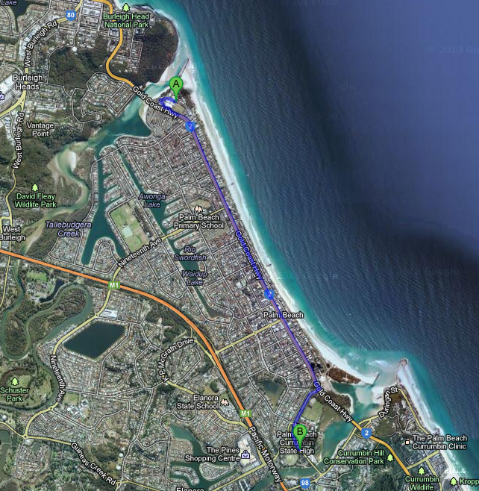

DIRECTIONS – Tallebudgera Active Recreation Centre (A) to Palm Beach Currumbin Pool (B)

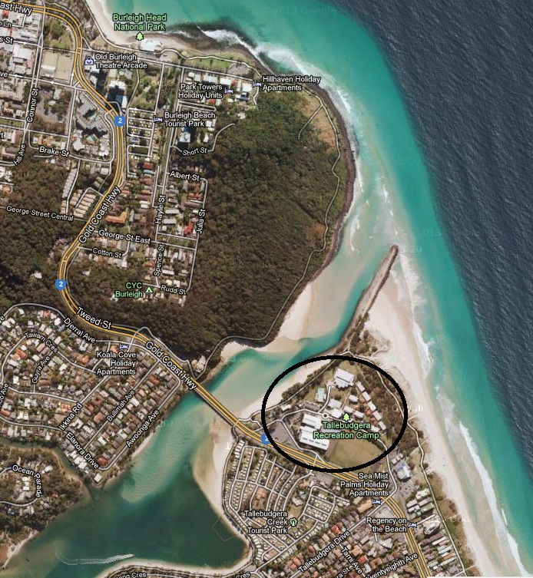

ACCOMODATION – Tallebudgera Active Recreation Centre (Circled)

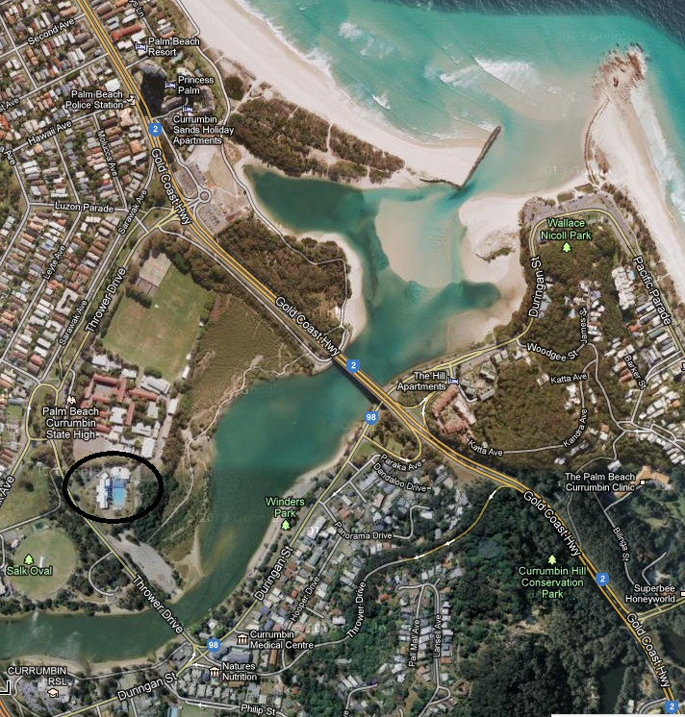

COMPETITION VENUE – Palm Beach Currumbin Pool (Circled)

